 |   BHARAT SANCHAR NIGAM LIMITED  (A Government of India Enterprise)  Corporate Office (Revenue Management Branch - CFA)  2nd floor, Room No. 216, Eastern Court, Janpath,  NEW DELHI-110 001
No. 2-9/2010-BSNL/TR Dated: 28-02-2013
To
- CGM, ITPC, BSNL, Pune.
- All Heads of Telecom Circles and Metro Telephone Districts,
Bharat Sanchar Nigam Limited.

Subject: - Withdrawal of scheme of allowing 1% discount on payment of Landline telephone bills through certain specific modes of payment like ECS/Online portal/ATMs etc.

The matter of withdrawal of the scheme of allowing discount on payment of Landline telephone bills through certain specific modes of payment like ECS/Online portal/ATMs etc. has been under consideration in this office for some time. In this regard the Competent Authority has approved discontinuance of allowing discount @1% (One percent) which is being presently allowed on payment of telephone bills through certain specific modes of payment like ECS, Payment through ATMs, Payment at BSNL’s All India bill payment portal/ Circle portals etc.

Approval of the Competent Authority is, therefore, hereby conveyed for withdrawal of scheme of allowing discount @ 1% (One percent) to BSNL customers on payment of telephone bills through the aforesaid modes of payment with effect from 1st April, 2013.

In this context, all the concerned are requested to observe the following procedure while implementing the decision being conveyed through this circular: -

- The necessary processes involved in making suitable modifications and all associated activities in all the Commercial/Billing and Accounting Systems including CDR System should be completed by 31st March, 2013 by the ITPC, Pune. All the Telecom. Circles/Districts should also make necessary modifications in the activities associated with Billing and Accounting, in case such activities require modification consequent upon the withdrawal of the aforesaid scheme.
- All the references to the aforesaid discount on various web pages of BSNL Corporate web-site, Circle web-site, printed publicity material, messages on SMS/ e-mail/ IVRS or messages on printed bills/ receipts etc. should be withdrawn timely so that no such reference gets quoted or exists after withdrawal of the scheme. Such information wherever available, should simply be removed, instead of modifying the same to state that the scheme has been withdrawn.
- It must also be ensured that suitable messages for availability of payment options like online payments on BSNL web site, at ATMs etc. inter-alia as different modes of payment of Landline telephone bills should continue to be displayed.
- In case of preprinted stationery and other pre printed marketing material, where the message of availability of discount @ 1% for online payments etc. is printed, it will be necessary to print another message on the bill stating that “Scheme of 1% discount for online/ ECS payment stands withdrawn w.e.f. 1st April, 2013, the earlier message of admissibility of such discount may be ignored.” Similar messages should be stamped on the preprinted marketing material also, till the existing stock of such stationery gets exhausted.
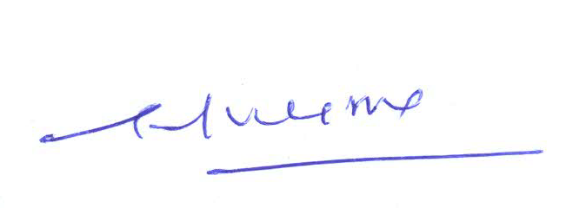
- Implementation of these instructions be ensured by the ITPC and Telecom. Circles / Metro Telephone Districts and a report on implementation may be sent to this office by 31st March, 2013 positively.

(G. P. Verma)
G. M. (Finance) – CFA
Copy for kind information to:
- CMD, BSNL
- Director (CFA/CM/EB/NB) BSNL Board
- ED (Finance), CO BSNL
- Sr. GM (NWO-CFA)
- Sr. GM (IT-CFA) CO BSNL to pursue the matter for updation of information on BSNL web sites in line with the instructions contained in this circular.
- GM (RA), CO BSNL ND
- GM (Finance), ITPC, Pune for necessary action.

